A100 Solar System – Homework 5: Morning Star, Evening Star

Due October 24 Name______________________________

For this assignment, you should use the NASA JPL Solar System Simulator at space.jpl.nasa.gov. Set it to show "The Solar System" from above, with the date of your choice. Select a field of view of 2 degrees. The Simulator can also display how Venus looks from Earth (set the field of view to 0.1 degrees).

1. Use the Simulator to obtain a view of the positions of Earth, Venus, and the Sun on each of the following dates, and indicate the positions of both planets on the diagrams below.

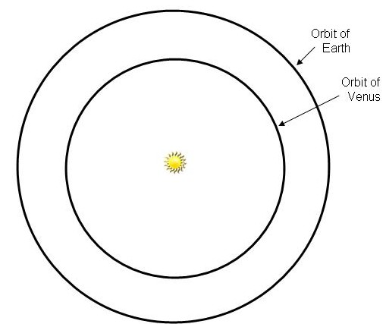

Sept. 15 Oct. 15 Nov. 15

2. For each date, use the Simulator to obtain a view of how Venus will appear from Earth and sketch its appearance for each date below.

Sept. 15 Oct. 15 Nov. 15

3. Where should you look in the sky to find Venus in October? What time of night will it be visible?

4. Use the Simulator to determine when Venus will reach inferior conjunction – a position between the Earth and the Sun. Date of inferior conjunction____________________.

5. Sketch the appearance of Venus, as seen from Earth, one month before and one month after inferior conjunction.

One month before One month after

