Finding Dusty Disks

Background Science

Planets orbiting stars other than the Sun are hard to find. They often orbit too close to their central stars and are too faint to see directly in the bright glare of the central star. Astronomers must use indirect means to detect the presence of planets around other stars.

The process of star formation leads to the formation of a disk of rocky or icy debris circling the central star. This debris disk may be similar to the large "asteroid belt" between the orbits of Mars and Jupiter in our own solar system. Planets disturb the orbits of bodies in the debris disk, causing collisions, which produce dust. Dust is expelled from the system in less than a million years. If dust is present around the star, then some source must be producing new dust. The presence of dust around a star is a strong indication of the presence of planets around the star.

Cool dust around other stars emits energy in the infrared portion of the electromagnetic spectrum that can be detected with the Spitzer Space Telescope. Stars with excess brightness at infrared wavelengths probably are surrounded by dust, and may well host extra-solar planets.

In this activity, students will examine infrared images of stars in the star cluster IC 4665 to identify those that might harbor planets.

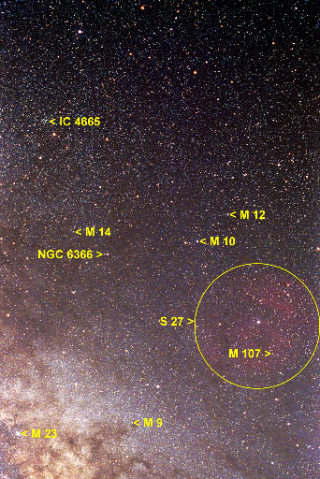
What are Star Clusters?

Star clusters are groups of stars that form together from a cloud interstellar gas within a short time. The stars usually remain together through their mutual gravitational attraction. The diameter of the star cluster IC 4665 is about 5 parsecs, or about 16 light years. Within a sphere 16 light years in diameter are hundreds of stars belonging to IC 4665. Because the distance to IC 4665 (352 parsecs) is so much greater than its diameter (5 parsecs), we can assume that all the stars in the cluster are effectively the same distance from the Sun.

About IC 4665

IC 4665 is a large cluster of stars in the direction of the constellation Ophiuchus. Its age is estimated from the main sequence stars in the cluster to be between about 30-100 million years, and its distance is about 352 parsecs (1150 light years). The brightest star thought to be a member of IC 4665 is just slightly fainter than can be seen with the naked eye. IC 4665 can be seen with binoculars near the bright star Beta Ophiuchi (Beta Ophiuchi is not associated with the cluster). The cluster can seen in the adjacent image (© T. Credner & S. Kohle, AlltheSky.com), which shows a broad region of sky in the direction of the constellation Ophiuchus, including other star clusters, such as the globular clusters Messier10 and Messier 12.

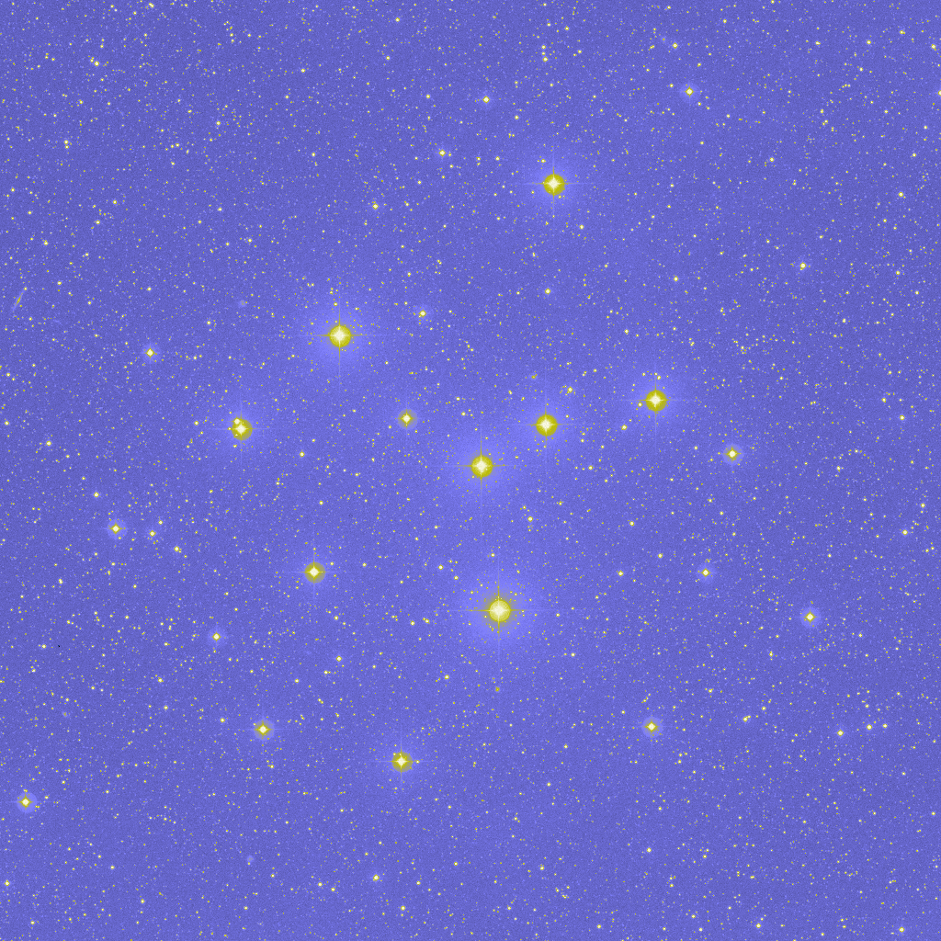
A blowup of the cluster IC 4665 is shown to the left, obtained from the Skyview website at the Goddard Space Flight Center (http://skyview.gsfc.nasa.gov). Here the stars of the cluster are shown as bright dots against a blue sky background. The size of the dot is related to the brightness of the star, and the faintest stars are barely discernible against the sky background. In this image, north is at the top, and east is to the left, as is standard practice for astronomical images. Most of the brightest stars in the image are members of IC 4664, but most of the faint stars are either foreground or background stars that are not associated with the cluster. These stars lie either in front of or behind the cluster itself.

Measuring the Brightness of Stars

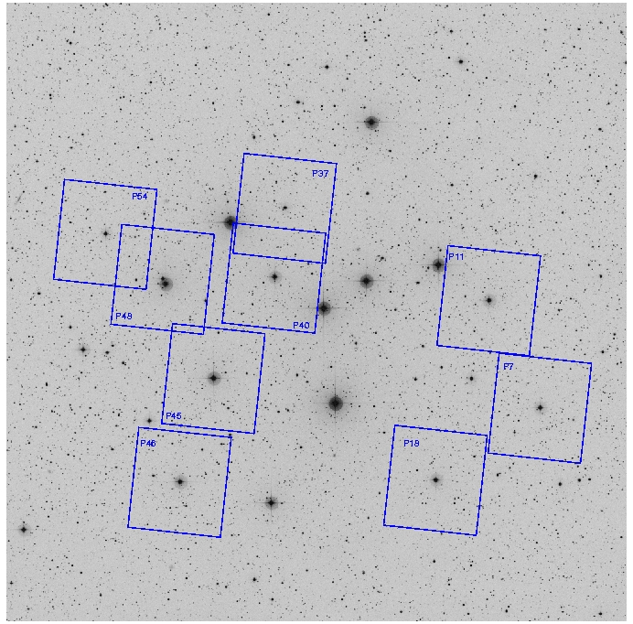
In the image of the cluster IC 4664 to the left, the sky is shown as light with black stars. Astronomers usually work with a "negative" display of images of the sky because the stars are easier to see. The small (5' x 5') regions of sky imaged by the MIPS instrument on Spitzer are shown as small rectangles, and the stars in the centers of each rectangle are the targets of this investigation.

The stars are identified according to the numbering scheme devised by astronomer Charles Prosser in 1993. Prosser measured the proper motion (the motion of stars in the plane of the sky) to determine which stars in the vicinity of the cluster are actually members and which are foreground or background stars. He also measured the brightness of the stars in three different colors or wavelengths of light using three filters labeled B (blue), V (visual) and I (near-IR). Additional near infrared measurements for stars in IC 4665 are available from the 2 Micron All Sky Survey.

The brightness of stars in IC 4665 for the wavelength regions B, V, I, J, H, and K are included in the table below. These measurements are published in the astronomical literature, as noted in the references below the table.

Wavelengths are measured in nanometers (nm, 10⁻⁹ meters). Visible light has wavelengths between 400 and about 700 nm. The B, V, and I filters cover the wavelength ranges from 390 – 490 nm, 500 – 590 nm, and 760 – 1000 nm, respectively. These wavelength ranges are known as "passbands." Infrared light has longer wavelengths, up to about 200,000 nm (0.2 mm). The J, H, and K passbands correspond to wavelengths of 1,235, 1,662, and 2,159 nm. Wavelengths longer than 200,000 nm are considered "sub-millimeter," microwave, or radio waves. The Spitzer observations for this activity were obtained at a wavelength of 24,000 nm (24 μm or 0.024 mm), in the mid-infrared range of the spectrum.

The flux density (brightness) of a star in each waveband is measured in units of milli-Jansky. A Jansky is 10⁻²⁶ watts per square meter per frequency interval (and a milli-Jansky is 10⁻²⁹ watts per square meter per frequency interval). A special unit for such a small amount of energy is needed to describe the brightness of astronomical sources because, being at very large distances, the stars appear to be extremely faint.

The graph labeled "Flux Densities for IC 4665" displays the expected brightness of stars of different temperatures at a distance of 352 parsecs, the distance of the cluster IC 4665. The flux curves for temperatures from 5,000 to 12,000 K (degrees Kelvin) have been computed using basic physical constants, the Planck function, and estimates of the radii of stars at each temperature. The brightness of stars is a function of temperature (hotter stars are brighter at each wavelength), radius (bigger stars are brighter, and hotter stars have larger radii than cooler stars), and distance (through the inverse square law).

Step 1: Determine the approximate temperature of each star. Plot the brightness of each (flux density, in mJy) as a function of wavelength (in nm) on the Flux Density Chart. Use a different colored pencil for each star, and plot the data for the passbands B, V, I, J, H, and K.

Step 2: Sketch a black body curve for each star that is parallel to the calculated curves and passes through the data points for the star. Use your sketched curve to estimate the flux density to be expected for each star at 24,000 nm based on the black body curves.

Step 3: Use the Sky Image Processor (SIP) available from the Virginia Technical Institute to measure the flux densities of the target stars at 24,000 nm.

Images of stars in IC 4665 were obtained with the "Multi-band Imaging Photometer for Spitzer" (MIPS) camera on the Spitzer Space Telescope. The images each cover a small patch of sky (a square about 5 arc minutes on a sky, equivalent to about 1/30 the area of the full moon), and the target stars are located at the center of each image. The MIPS camera produces pictures with 183x202 pixels. The images were recorded at a wavelength of 24,000 nm. The Spitzer images are available on the CD. The images are in a special format called "FITS" (Flexible Image Transport System) that allows us to make quantitative measurements of the brightness of stars.

To start SIP, open a browser and link to the website http://www.phys.vt.edu/~jhs/SIP/. Click the "start SIP" button to begin a session. A SIP image window will open on your computer.

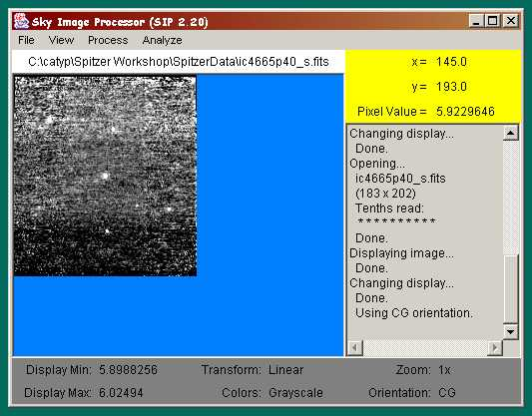

Load the IC 4664 image CD into the computer. Using the SIP file menu, select "Open Image File from User's Machine" and browse to select one of the .fits images on the CD. The image should load into the display window. (Sometimes, only a partial image is displayed. If this is the case, select "Conventional FITS Image Orientation" under the "view" menu to display it again. It may be easier to see the star if you click “Automatic Contrast Adjustment” under the “View” file menu.)

To measure the flux density of a star in the image (our targets are located at the center of each image), use the "Determine Centroid or Instrumental Magnitude of an Object" in the "analyze" menu. Two squares will appear in the image (a red target box and a green background box), and a control panel will appear. Select "Background annulus centered on target box" and use the sliders in the control panel to center the boxes over the star to be measured. Adjust the background annulus box to encompass a representative area around the star, but to avoid including any light from the star itself.

The applet will add up the flux in the target box, and subtract an estimate of the background flux based on the light included in the background annulus. The applet automatically corrects for the different areas of the two boxes.

Note: Some of the targets have nearby companion stars. In those cases, use the "background box" option to avoid including the companion star in the background measurement.

Record the "object flux" shown at the bottom of the control panel for each star in the sample.

Note: If the program should freeze up, you may need to exit your web browser, then reopen it and go back to the web site. This should free it up.

Step 4: Plot the measured Spitzer fluxes on the Flux Density Chart using the same colored pencils as before. The wavelength of the Spitzer images is 24,000 nm.

Identify any stars with excess infrared fluxes at 24,000 nm. An infrared excess is more than a factor of two above the expected flux density predicted by the black body curves. Stars with infrared excesses probably contain an extended dust disk around the star, and may harbor planets.

Flux Density Measurements in mJy for IC 4665 Targets
 |  |  |  | 2MASS Infrared Fluxes
Waveband: | B (blue) | V (visual) | I (near IR) | J | H | K
Wavelength (nm): | 440 | 550 | 970 | 1235 | 1662 | 2159
Star ID
Prosser 7 | 586 | 675 | 551 | 517 | 364 | 246
Prosser 11 | 839 | 882 | 615 | 571 | 385 | 252
Prosser 18 | 780 | 890 | 693 | 642 | 442 | 299
Prosser 37 | 217 | 257 | 207 | 189 | 136 | 89.9
Prosser 40 |  | 547 |  |  | 272 | 211
Prosser 45 | 1920 | 1970 |  | 1110 | 770 | 478
Prosser 46 | 1060 | 1080 | 732 | 622 | 387 | 274
Prosser 48 | 256 | 303 | 236 | 234 | 160 | 108
Prosser 54 | 398 | 438 | 332 | 294 | 203 | 143
Sources:
BVI Photometry: Prosser, C. F. 1993, Astronomical Journal, 105, 1441
2MASS IR Photometry: This activity makes use of data products from the Two Micron All Sky Survey, which is a joint project of the University of Massachusetts and the Infrared Processing and Analysis Center/California Institute of Technology, funded by the National Aeronautics and Space Administration and the National Science Foundation (http://www.ipac.caltech.edu/2mass/).

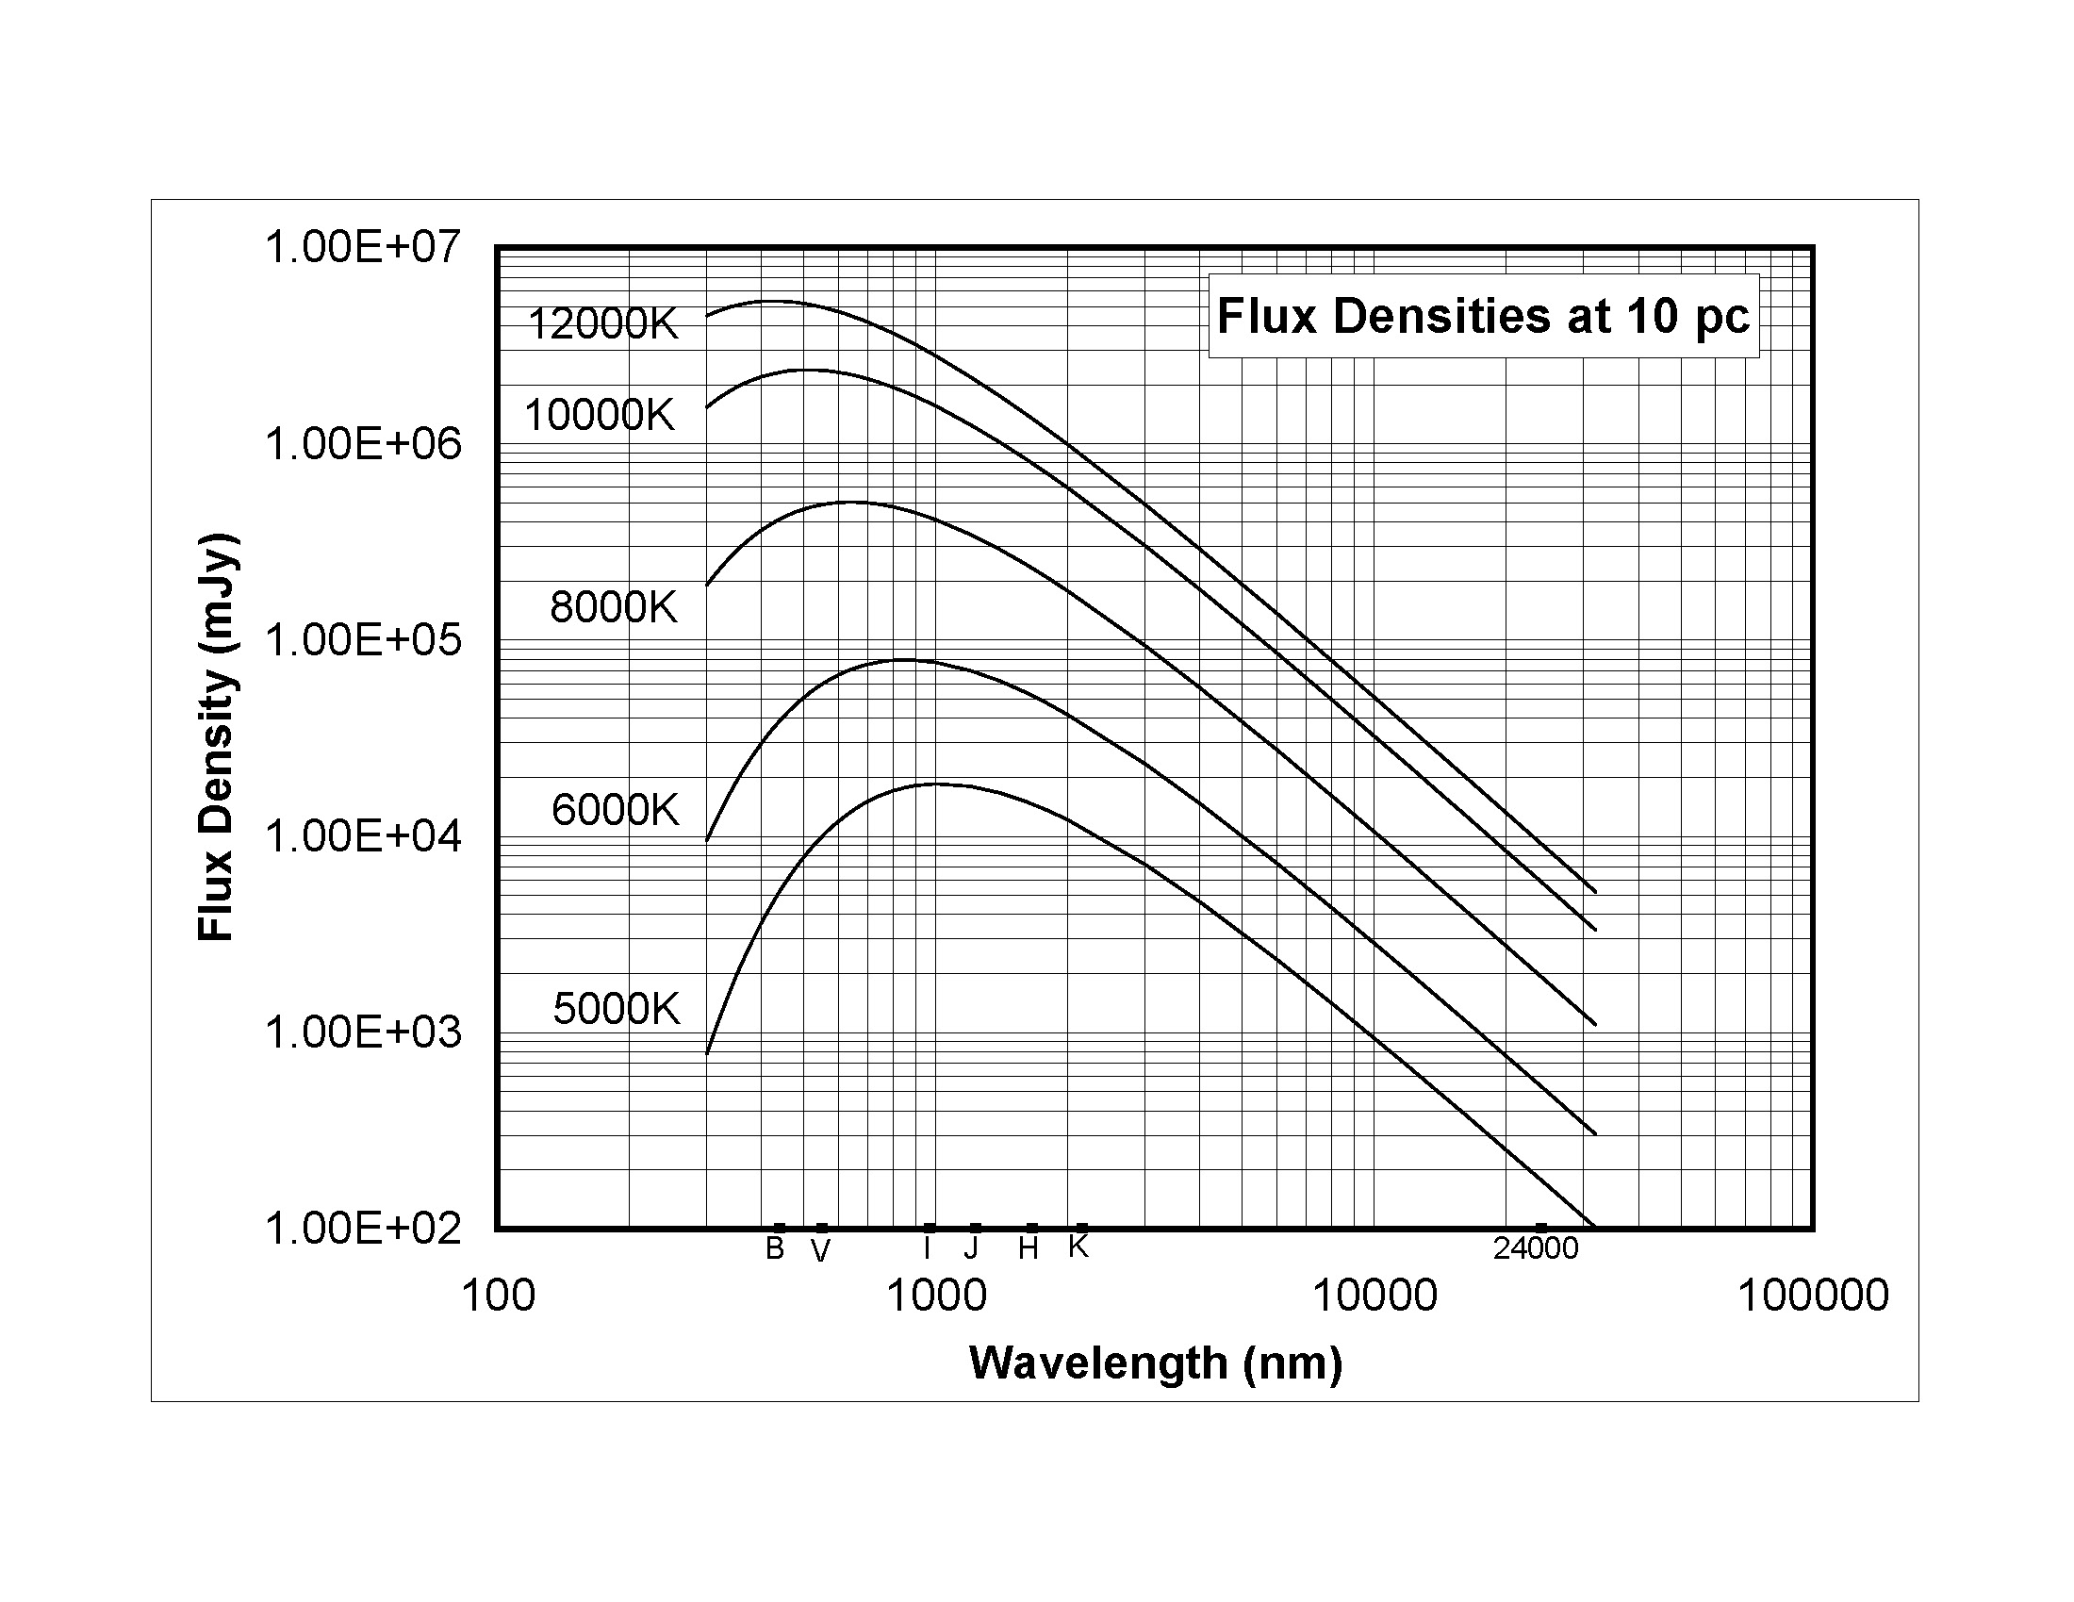

The Sky Image Processor (SIP) was prepared by John H. Simonetti of the Virginia Technical Institute

